Introduction to Biometric
Biometrics refers to the measurement and statistical analysis of people's unique physical and behavioral characteristics. The technology is primarily used for identification and access control, or for identifying individuals who are under surveillance. The basic premise of biometric authentication is that every person is unique and an individual can be identified by his or her intrinsic physical or behavioral traits.
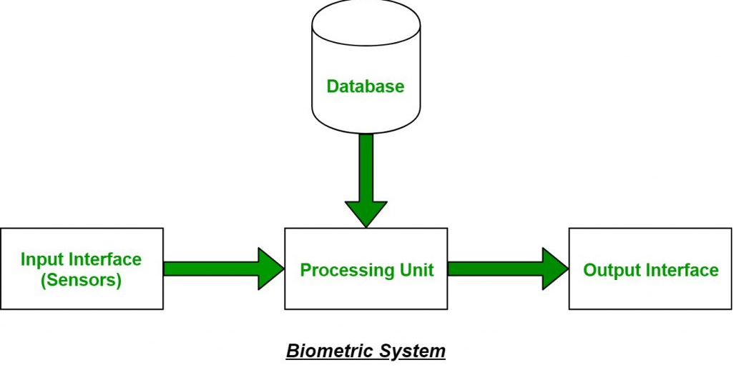

Types of Biometrics:
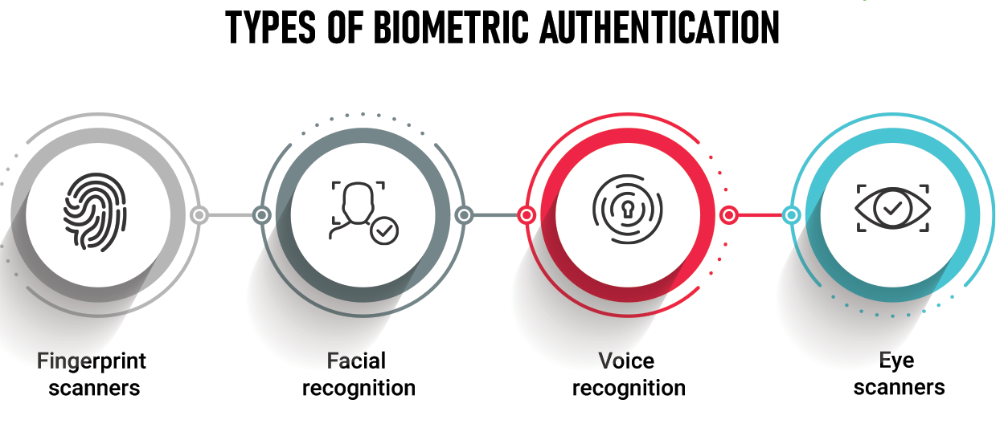
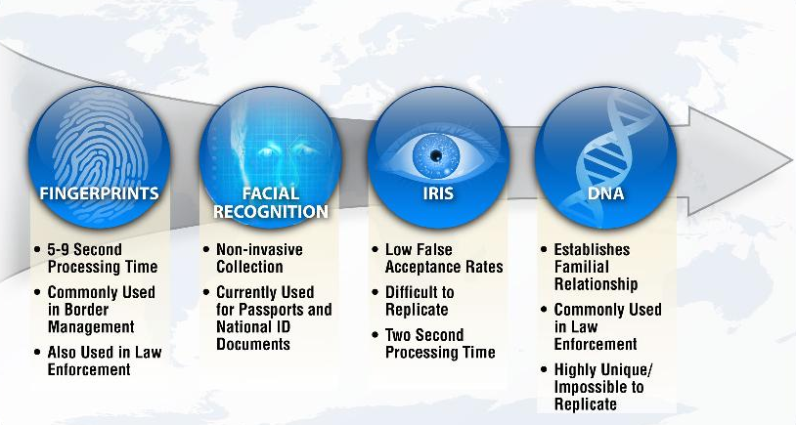
Biometric technology is more refined, advanced, and super sensitive. It protects companies and individuals. Most importantly, it is impossible to duplicate biometrics works on biological characteristics of an individual.
An individual has two types of biological traits: behavioral and physical.
So, there are two types of biometrics: Behavioral Biometrics and Physiological Biometrics.

Behavioral Biometrics
Behavioral Biometrics is the scientific study of how people's and animals' bodies function.
It is further divided into:
- Signature Recognition
- Voice Recognition
- Keystroke

Physiological Biometrics
Physiological biometrics is based on a behavioral trait of an individual. It involves all physical characteristics like, ears, eyes, iris, fingerprints, etc.
It is further divided into:

- Ear authentication
- Eye vein recognition
- Facial recognition
- Finger vein recognition
- Fingerprint recognition
- DNA matching
- Footprint and foot dynamics
- Gait recognition

1.Fingerprint Recognition: One of the oldest and most common forms of biometric identification. A fingerprint is made up of a pattern of ridges and furrows as well as characteristics that occur at minutiae points (ridge bifurcation or a ridge ending).
2.Facial Recognition: This involves analyzing the characteristics of a person's face images captured through an image or video. It compares the features of the face to those of known faces on a database.
3.Iris Recognition: This method uses the unique patterns of a person’s iris. These patterns are extremely complex and can be seen from some distance.
4.Voice Recognition: This identifies and authenticates a person based on their voice patterns. Voice recognition systems analyze the voice biometrics including pitch, speech, tone, and frequency.
5.Hand Geometry: This involves the measurement of the shape of the hand and the lengths of the fingers. Typically used in less secure, high-throughput settings.
6.Behavioral Biometrics: These include keystroke dynamics, gait analysis, and signature analysis. This category is unique because it's based on the behavior of a person, which can change over time.
Advantages:
- High level of security and accuracy.
- Difficult to forge or steal.
- Convenient and fast.
Disadvantages:
- Privacy concerns, as biometric data can be sensitive.
- Expensive to implement and maintain.
- Potential errors, such as false positives and false negatives.
- Ethical concerns around surveillance and misuse of data.
Future Trends in Biometrics:
The future of biometrics could see the integration of multiple biometric technologies for enhanced security (multimodal biometrics), the use of biometrics in blockchain and cryptocurrency transactions, and advancements in AI and machine learning to improve accuracy and fraud detection. Additionally, there's a growing trend towards developing methods that are less intrusive and respect user privacy.

Benefits of biometrics over traditional authentication system
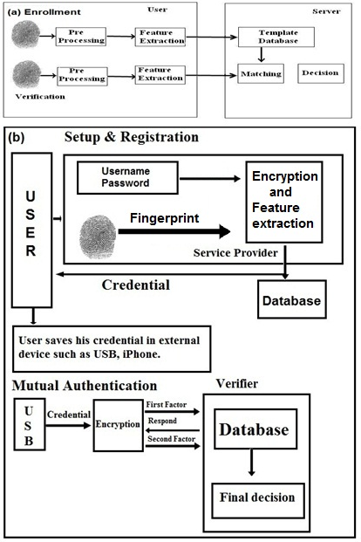
Biometric authentication systems offer several advantages over traditional authentication methods, such as passwords, PINs, or physical tokens. Here are some of the key benefits:
- Enhanced Security: Biometric characteristics are unique to individuals, making it significantly harder for an unauthorized person to gain access. Unlike passwords or PIN codes, biometric traits cannot be easily guessed, stolen, or shared.
- Reduced Risk of Lost or Stolen Credentials: Traditional security methods suffer from the risk of lost or stolen keys, cards, or forgotten passwords. Biometrics are inherently tied to an individual and cannot be lost or stolen in the same way.
- Non-transferable: Biometric traits are inherently linked to the individual, making them non-transferable. This reduces the risk of unauthorized access that can happen with traditional methods like sharing or borrowing keys or access cards.
- Convenience: Biometrics can offer a more convenient user experience. Users do not need to remember passwords or carry tokens – they just use their inherent physical or behavioral traits, such as fingerprints or facial features.
- Time Efficiency: Biometric systems can be faster than typing a password or using a key. For instance, a quick fingerprint or facial scan can unlock a device or provide access much faster than manual entry methods.
- Non-repudiation: It's more challenging for a user to deny actions or transactions authenticated through biometric systems since these are uniquely linked to the individual.
- Reduced Administrative Costs: Biometric systems can reduce costs related to resetting passwords, managing lost or stolen access cards, or other administrative issues associated with traditional authentication systems.
- User Experience: For many users, biometrics offer a modern, high-tech experience. This can lead to higher user satisfaction and perception of advanced security.
- Scalability and Integration: Modern biometric systems are increasingly scalable and can be integrated with existing security infrastructures, enhancing overall security without a complete overhaul of existing systems.
- Deterrence of Fraud and Theft: The presence of biometric systems can act as a deterrent to fraud and theft, as perpetrators recognize the higher risk of being identified and caught.

However, it's important to note that biometrics are not without their challenges and limitations. Issues related to privacy, the potential for errors (like false positives or negatives), and the need for robust data protection measures are important considerations. Additionally, there can be concerns about the collection and handling of biometric data, which is sensitive personal information.

Benefits of biometric identification system
Biometric identification systems offer several significant benefits, particularly when compared to traditional forms of identification like ID cards, passwords, or PINs. These advantages stem from the unique nature of biometric data – such as fingerprints, facial recognition, iris scans, or voice patterns – which are inherently linked to individual users. Here are some of the key benefits:
- Increased Security: Biometric identifiers are unique to each individual and are much more difficult to forge or manipulate compared to traditional identification methods. This heightened security is crucial in applications like access control, financial transactions, and confidential data protection.
- Reduced Fraud and Identity Theft: Since biometric characteristics are inherently personal and cannot be easily shared or stolen, the use of biometrics significantly reduces the risk of identity theft and fraud.
- Convenience: Biometrics provide a convenient way for users to identify themselves. There's no need to remember passwords or carry identification cards. A simple scan of a fingerprint or face can grant access or verify identity.
- Accuracy: Biometric systems tend to be more accurate in verifying identity. They reduce the chances of false identifications and unauthorized access which are more likely with password-based or card-based systems.
- Time Efficiency: Biometric identification processes are typically quick and automated, leading to faster verification and less time spent on authentication procedures.
- Non-repudiation: Biometrics can provide strong evidence of a person's identity, making it difficult for individuals to deny their actions or involvement in a transaction.
- Improved User Experience: Users often find biometric systems to be more user-friendly compared to remembering multiple passwords or carrying additional tokens or ID cards.
- Cost-Effectiveness: In the long run, biometric systems can be cost-effective for organizations, as they reduce the need for physical security controls, password management systems, and the administrative burden associated with lost or forgotten passwords or ID cards.
- Scalability and Integration: Modern biometric systems are designed to be scalable and can be integrated into various platforms, enhancing the overall security infrastructure of an organization without requiring a complete overhaul.
- Audit Trails for Transactions: Biometrics can provide clear and auditable records of transactions and accesses, which is crucial in sensitive environments like financial services, healthcare, and government operations.
- Deterrence: The presence of biometric systems can act as a deterrent to potential wrongdoers, as they are aware that their biometric data could be used to trace and identify them.
It's important to recognize that while biometric identification systems offer many benefits, they also raise concerns related to privacy, data security, and the need for careful handling of sensitive biometric data. Balancing these concerns with the advantages is a key challenge in the broader adoption of biometric technology.
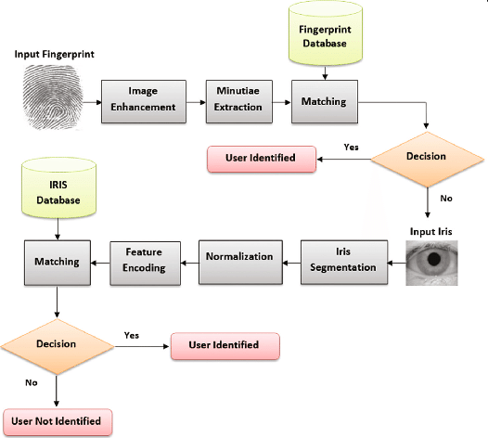
Selecting a biometric for a system
Selecting the appropriate biometric for a system requires careful consideration of various factors, as the choice significantly impacts the system's effectiveness, user acceptance, and overall security. Here’s a guide to help you in selecting the most suitable biometric modality for your specific application:
Purpose and Scope of the System:
- Security Level Required: High-security applications (like government or military systems) may need more secure biometrics like iris or vein pattern recognition, while less sensitive systems can use fingerprints or facial recognition.
- Scale of Use: Consider whether the system is for a small group (like corporate access control) or a large population (like national ID systems).
User Acceptance and Convenience:
- Cultural and Social Factors: Some biometrics may be more culturally accepted than others. For instance, certain cultures might have reservations about fingerprinting but are more open to facial recognition.
- Ease of Use: Systems should be user-friendly. Biometrics like facial recognition and fingerprints are generally more user-friendly compared to more intrusive methods like iris scans.
Accuracy and Performance:
- False Acceptance Rate (FAR) and False Rejection Rate (FRR): Evaluate the system’s accuracy. A high FAR means unauthorized users could gain access, while a high FRR means legitimate users could be denied access.
- Speed of Processing: Consider how fast the system needs to process identifications. Some biometrics are faster than others.
Environment and Usage Conditions:
- Physical Environment: The environment where the system will be used can impact performance. For example, fingerprint scanners may not work well in very dusty or wet environments.
- Ergonomics: The physical setup should be considered. For instance, systems requiring users to reach or bend might be unsuitable for certain users.
Cost Considerations:
- Initial Setup Cost: Some biometric systems, like iris recognition, require expensive equipment, while others, like fingerprints, are more cost-effective.
- Maintenance and Operational Costs: Consider long-term costs, including maintenance and potential software updates.
Integration with Existing Systems:
The new biometric system should be compatible with existing security infrastructures and technologies.
Privacy and Legal Considerations:
- Data Protection Laws: Ensure the system complies with privacy laws and data protection regulations.
- Storage and Handling of Biometric Data: Plan for secure storage and handling of sensitive biometric data.
Reliability and Durability:
Choose hardware and software known for reliability and durability, especially in systems that will be used frequently or in challenging environments.
Scalability:
The system should be scalable to accommodate future growth or changes in user numbers.
Vendor Reputation and Support:
Choose reputable vendors with good support and track records. This ensures you get quality hardware, software, and customer service.
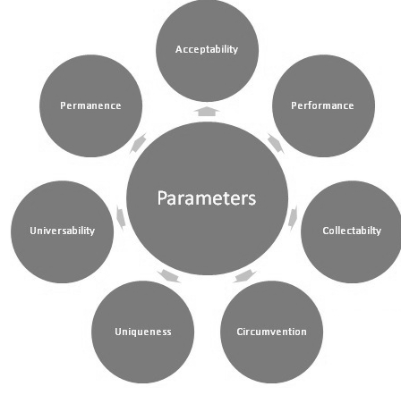
Applications of Biometrics:
Security and Access Control: Biometrics is commonly used for granting access to buildings, rooms, and computer systems.
Time and Attendance Systems: Replacing traditional time cards and badges with biometric time clocks.
Law Enforcement: Used in criminal identification and prison security.
Travel and Immigration: Biometrics is used in passports, visas, and in airports for security checks.
Banking and Finance: For secure transactions and authentication in ATMs and mobile banking.
Healthcare: For patient identification and record management.

Biometric security systems have a wide range of applications across various sectors due to their ability to provide secure and convenient identification and authentication based on unique biological characteristics. Here are some key areas where biometric security is applied:
- Access Control: Biometrics are widely used to control access to physical spaces like buildings, offices, and restricted areas in airports or government facilities, as well as digital spaces like computer networks, databases, and other IT systems.
- Mobile Device Security: Smartphones and tablets increasingly use biometrics (fingerprint scanning, facial recognition, or iris scanning) to unlock devices and authenticate users for various applications, including mobile banking and personal data access.
- Banking and Financial Services: Biometrics are used for customer identification in banks, ATMs, and online banking platforms. They help in reducing fraud, especially in transactions and personal banking services.
- Law Enforcement and Public Safety: Police and other law enforcement agencies use biometrics for identifying suspects, criminals, or victims using fingerprints, facial recognition, DNA, and iris scanning. Biometric technology also plays a crucial role in border control and immigration processes.
- Healthcare Systems: Patient identification and access to medical records are secured through biometrics. This helps in preventing medical identity theft and ensures that medical records are only accessible to authorized individuals.
- Travel and Immigration: Airports and border control use biometrics for traveler identification and passport control. This enhances security and streamlines the immigration process, reducing waiting times and preventing passport fraud.
- Workforce Management: Biometric systems are used for employee identification and for tracking time and attendance, replacing traditional timecards and badges, which can be lost or manipulated.
- Consumer Electronics: Biometric security is increasingly common in consumer electronics for user authentication, such as in laptops, external hard drives, and smart home systems.
- Education Sector: Biometric systems are used for controlling access to facilities, tracking attendance, and even in library systems within educational institutions.
- Retail and E-commerce: Some retail environments use biometrics for customer payments and to personalize the shopping experience, as well as for controlling access to warehouses and inventory management.
- Automotive Industry: Biometric technology is being integrated into vehicles for driver identification, personalization of settings (seat position, mirror adjustments, infotainment system), and as an anti-theft measure.
- Government Services: Biometrics are used in various government services, including voter registration, social security, and public welfare programs to ensure that services are provided to the intended recipients.
- Cybersecurity: Biometrics provide a layer of security for protecting data and access to computer systems and networks, preventing unauthorized access and data breaches.
As biometric technology continues to evolve, its applications are expanding, offering new and innovative ways to enhance security and convenience in both public and private sectors. However, this also raises important questions and challenges related to privacy, data protection, and ethical considerations that need to be addressed.
Key biometric terms and processes
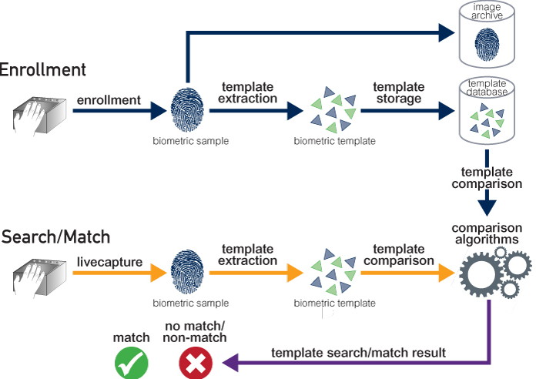
In the context of biometric security, several key terms and processes are fundamental to understanding how these systems operate. Here's an overview:
Key Terms:
- Biometric Security: The use of unique biological characteristics to identify and authenticate individuals for security purposes.
- Biometric Identifier: A distinctive, measurable characteristic used to label and describe individuals, typically for authentication purposes. Examples include fingerprints, facial patterns, iris structure, and voice.
- Sensor: A device that detects and captures biometric data. For instance, a fingerprint scanner or an iris scanning camera.
- Algorithm: A set of mathematical rules used in the biometric software to analyze the captured data and convert it into a biometric template.
- Biometric Template: A digital representation of an individual's distinct characteristics, extracted from the raw biometric data.
- Authentication: The process of verifying a person’s identity based on their biometric data.
- Access Control: Using biometrics to manage individuals' access to physical spaces or digital resources.
- Liveness Detection: A security feature used in biometric systems to detect and prevent spoofing or fake biometric traits.
- FAR (False Acceptance Rate): The rate at which unauthorized users are incorrectly accepted as legitimate by the biometric system.
- FRR (False Rejection Rate): The rate at which legitimate users are incorrectly rejected by the biometric system.
- Threshold: The sensitivity of the biometric system, balancing between FAR and FRR. Setting the threshold is crucial for determining the trade-off between security and convenience.
Processes:
Enrollment:
- Capture: Collecting the raw biometric sample.
- Feature Extraction: Analyzing the sample to extract unique features.
- Template Creation: Generating a digital biometric template from the extracted features.
- Storage: Securely storing the biometric template for future comparison.
Verification Process:
- Capture: Acquiring a fresh biometric sample from the user.
- Processing: Extracting features from the live sample.
- Comparison: Matching these features against a stored template.
- Decision: Authenticating the user based on the degree of match.
Identification Process:Similar to verification, but the live sample is compared against multiple templates to establish an individual’s identity without prior claim of identity.
System Integration:Incorporating biometric hardware and software into existing security systems, like access control systems or IT network security.
Maintenance:Regular updates and checks to ensure the biometric system operates accurately and securely.
Compliance and Privacy Management:Ensuring the biometric system complies with legal standards, especially regarding data protection and user privacy.
Biometric Matching Methods
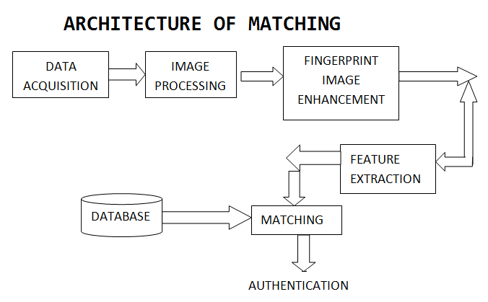
In biometric security systems, matching methods are crucial for comparing collected biometric data against stored templates to authenticate or identify individuals. There are two primary types of biometric matching methods:
1. One-to-One Matching (Verification):
- Description: Also known as verification, this method involves comparing the biometric data of an individual against a specific, previously stored template to verify the individual's claimed identity.
- Usage: Commonly used in access control systems, mobile device unlocking, and computer login systems.
Process:
- An individual claims an identity (e.g., entering a username).
- The system captures the biometric data (like a fingerprint or facial scan).
- The captured data is processed and compared with the stored template associated with the claimed identity.
- If the data matches the template within predefined thresholds, the identity is verified; otherwise, access is denied.
2. One-to-Many Matching (Identification):
- Description: This method compares an individual's biometric data against all the templates in a database to establish the individual's identity without any prior identity claim.
- Usage: Often used in surveillance systems, forensic investigations, and large-scale identification systems like national ID programs.
Process:
- Biometric data is captured with no identity claim made.
- The system processes this data and searches the entire database of templates for a match.
- If a matching template is found, the system identifies the individual. If no match is found, the individual remains unidentified.
Additional Concepts in Biometric Matching:
- Adaptive Matching: Some advanced systems can update stored templates over time to adapt to changes in biometric data due to aging, injuries, or other factors.
- Fusion Matching: In multimodal biometric systems, data from different biometric modalities (like fingerprint and iris) are combined and used for matching, enhancing accuracy and security.
- Template Matching Algorithms: Depending on the biometric modality, different algorithms are used for matching. For instance, fingerprint matching algorithms analyze minutiae points, while facial recognition systems analyze facial features like the distance between eyes, nose shape, etc.
- Thresholds and Sensitivity: The system's sensitivity to matches is adjusted using thresholds. A lower threshold may reduce the False Rejection Rate (FRR) but increase the False Acceptance Rate (FAR), and vice versa.
- Quality of Biometric Data: The accuracy of matching heavily depends on the quality of the captured biometric data. Poor quality data (like a blurred fingerprint or low-resolution facial image) can lead to higher rates of false rejections or false acceptances.
- Privacy and Security in Matching: It's crucial to ensure that the matching process is secure and respects user privacy. This often involves encrypting biometric data and ensuring that templates do not reveal sensitive personal information.
By understanding these biometric matching methods and related concepts, one can appreciate how biometric systems authenticate and identify individuals in various security contexts, and the challenges involved in balancing convenience, accuracy, and privacy.
Accuracy in biometric system
Accuracy in biometric security systems is crucial, as it determines the effectiveness of the system in correctly identifying or verifying an individual's identity. The accuracy of a biometric system is typically assessed based on several key metrics:
1. False Acceptance Rate (FAR) or False Match Rate (FMR):
Definition: The probability that the system incorrectly matches the input sample with a non-matching template in the database. In other words, it's the likelihood of the system granting access to an unauthorized individual.
Impact: A high FAR is a security risk as it allows unauthorized access.
2. False Rejection Rate (FRR) or False Non-Match Rate (FNMR):
Definition: The frequency at which the system fails to recognize an authorized individual, rejecting their legitimate attempt to access.
Impact: A high FRR can lead to user frustration and reduced usability of the system.
3. Crossover Error Rate (CER) or Equal Error Rate (EER):
Definition: The point where the FAR and FRR are equal. This is often used as a general indicator of the system’s accuracy and performance.
Desirability: A lower EER indicates higher overall accuracy.
Factors Affecting Accuracy:
Quality of the Biometric Sample: Poor quality samples (blurry fingerprints, low-resolution facial images) can lead to errors in matching.
Biometric Sensor Quality: High-quality sensors capture more accurate and detailed biometric data, leading to better performance.
Algorithm Efficiency: The sophistication and effectiveness of the algorithm used for feature extraction and matching greatly influence accuracy.
User Interaction with the System: How a user interacts with the biometric system (e.g., positioning of finger on a scanner) can affect the quality of the captured biometric data.
Environmental Conditions: Factors such as lighting for facial recognition, or cleanliness of a fingerprint scanner, can impact the data quality.
Template Size and Quality: The size and quality of the biometric template stored in the system can influence the matching process.
System Configuration: The settings and thresholds for matching (like sensitivity and tolerance) need to be balanced between security (low FAR) and convenience (low FRR).
Improving Accuracy:
Using Multimodal Biometrics: Combining multiple biometric factors (like fingerprint and facial recognition) can greatly improve accuracy and security.
Regular System Updates and Maintenance: Keeping the biometric system updated with the latest software and maintaining the hardware properly.
User Education: Educating users on how to interact correctly with the biometric system.
Adaptive Biometric Systems: Systems that adapt to changes in biometric data over time (like aging in facial recognition) can maintain high accuracy.
Quality Control: Implementing measures to ensure high-quality data capture and template storage.
In summary, achieving high accuracy in biometric security systems is essential for ensuring reliable identification and authentication, balancing the trade-off between security (minimizing FAR) and user convenience (minimizing FRR). The overall goal is to create a system that is both secure and user-friendly.

Assignment-1
- What is biometric and types of biometric? Explain the features of biometrics.
- Write the two main functions of biometrics.
- How biometrics contrasts with traditional authentication methods?
- Explain the benefits of biometric approach vs traditional authentication methods.
- Write the benefits of using biometrics for identification.
- Explain the purpose of biometrics in security?
- Write the criteria for selecting biometric.
- Explain the application of biometrics in security?
- Write the four biometric functions of the biometric process.
- Explain the techniques of biometric matching.
- Which biometric method is best?
- How can the accuracy of two biometric systems which use different human characteristics be compared?

References for further Technical description

https://www.youtube.com/watch?v=Tlqbuon9o-0
https://www.youtube.com/watch?v=Io8sikVsMOw
https://www.youtube.com/watch?v=5_m2Md5s5K0
Difference between iris and retina scanning
https://www.youtube.com/watch?v=xb2DOIVGOlI
Retina Vascular pattern
https://www.youtube.com/watch?v=11V4w9oW1Vc
https://www.youtube.com/watch?v=9ks7K2GsDC0
https://www.youtube.com/watch?v=YzQbeFARnpw

